**NAME:** R.UMARANI

**DEPARTMENT:** B.E.COMPUTER SCIENCE AND ENGINEERING

**COLLEGE:** DHANALAKSHMI SRINIVASAN INSTITUTE OF TECHNOLOGY,SAMAYAPURAM,TRICHY.

**NAANMUDHALVAM COURSE:** DIGITAL MARKETING

**NM ID:** 3214C02177EFF91AC6D4E907102D3D42

**ASSIGNMENT ON DIGITAL MARKETING**

**1.Create a blog or Website using Blogspot and Wordpress. Customize the theme design and post new article with 500 words**

<https://draft.blogger.com/blog/posts/2232921793717483584>

<https://ramanapr21.wordpress.com/2023/10/20/motor-cycle/>

**2.Create a New Facebook Business Page and post one social media poster for**

**your brand.**

<https://m.facebook.com/story.php?story_fbid=pfbid0dAQGebkutd8heqiZEB4kiQamHmwfevrUxau1tRMjZAD8Bw2N3AHtHLcae7W1m9qCl&id=61550520728103&mibextid=Nif5oz>

**3.Create and design a social media advertisement poster using canva**

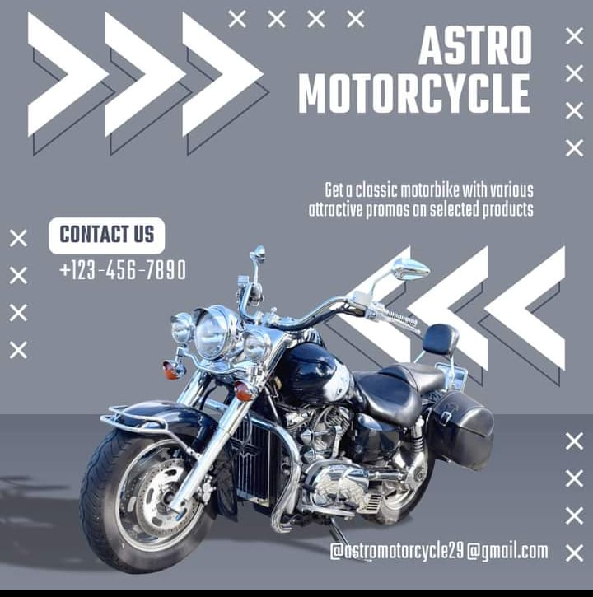

**4.Create email newsletter design using Mailchimp or canva tool**

